**2a) REQUEST DISPATCHER**

**File Name: index.html**

<html>

<head>

<title>TODO supply a title</title>

<meta charset="UTF-8">

<meta name="viewport" content="width=device-width, initial-scale=1.0">

</head>

<body>

**<form action="ValidateServlert" method="post">**

**Username:<input type="text" name="userName"/><br/>**

**Password:<input type="password" name="userPass"/><br/>**

**<input type="submit" value="login"/>**

**</form>**

</body>

</html>

**File Name: ValidateServlert.java**

package pack;

import java.io.IOException;

import java.io.PrintWriter;

import javax.servlet.RequestDispatcher;

import javax.servlet.ServletException;

import javax.servlet.http.HttpServlet;

import javax.servlet.http.HttpServletRequest;

import javax.servlet.http.HttpServletResponse;

public class ValidateServlert extends HttpServlet {

@Override

**protected void doPost(HttpServletRequest request, HttpServletResponse response)**

**throws ServletException, IOException {**

**response.setContentType("text/html");**

**PrintWriter out = response.getWriter();**

**String n = request.getParameter("userName");**

**String p = request.getParameter("userPass");**

**if(p.equals("servlet"))**

**{**

**RequestDispatcher rd = request.getRequestDispatcher("WelcomeServlet");**

**rd.forward(request, response);**

**} else {**

**out.print("Incorrect Username or Password!");**

**RequestDispatcher rd = request.getRequestDispatcher("/index.html");**

**rd.include(request, response);**

**}**

}

}

**File Name: WelcomeServlet.java**

package pack;

import java.io.IOException;

import java.io.PrintWriter;

import javax.servlet.ServletException;

import javax.servlet.http.HttpServlet;

import javax.servlet.http.HttpServletRequest;

import javax.servlet.http.HttpServletResponse;

public class WelcomeServlet extends HttpServlet {

@Override

**protected void doPost(HttpServletRequest request, HttpServletResponse response)**

**throws ServletException, IOException {**

**response.setContentType("text/html");**

**PrintWriter out = response.getWriter();**

**String n = request.getParameter("userName");**

**out.print("Welcome " + n);**

**}**

}

**Output:**

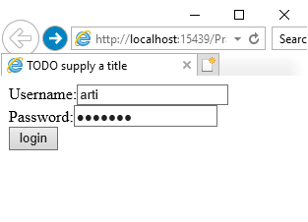 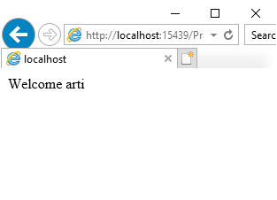

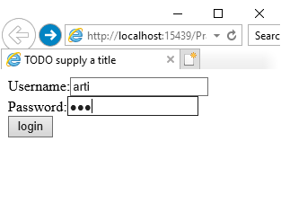 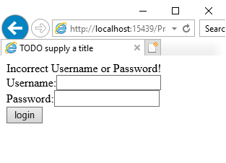

**2b) COOKIES**

**File Name: index.html**

<html>

<head>

<title>TODO supply a title</title>

<meta charset="UTF-8">

<meta name="viewport" content="width=device-width, initial-scale=1.0">

</head>

<body>

**<form action="Page1" >**

**Enter Your Name <input type="text" name="txtName"><br>**

**<input type="submit" value="Submit">**

**</form>**

</body>

</html>

**File Name: Page1.java**

package mypack;

import java.io.IOException;

import java.io.PrintWriter;

import javax.servlet.ServletException;

import javax.servlet.http.Cookie;

import javax.servlet.http.HttpServlet;

import javax.servlet.http.HttpServletRequest;

import javax.servlet.http.HttpServletResponse;

public class Page1 extends HttpServlet {

@Override

protected void doGet(HttpServletRequest request, HttpServletResponse response)

throws ServletException, IOException {

**response.setContentType("text/html;charset=UTF-8");**

**PrintWriter out = response.getWriter();**

**String uname = request.getParameter("txtName");**

**out.println("Welcome " + uname);**

**Cookie ck1 = new Cookie("username", uname);**

**Cookie ck2 = new Cookie("visit", "1");**

**response.addCookie(ck1);**

**response.addCookie(ck2);**

**out.println("<h1><a href='Page2'>Click to visit Page 2 </a></h1>");**

}

}

**File Name: Page2.java**

package mypack;

import java.io.IOException;

import java.io.PrintWriter;

import javax.servlet.ServletException;

import javax.servlet.http.Cookie;

import javax.servlet.http.HttpServlet;

import javax.servlet.http.HttpServletRequest;

import javax.servlet.http.HttpServletResponse;

public class Page2 extends HttpServlet {

@Override

protected void doGet(HttpServletRequest request, HttpServletResponse response)

throws ServletException, IOException {

**response.setContentType("text/html;charset=UTF-8");**

**PrintWriter out = response.getWriter();**

**Cookie[] ck = request.getCookies();**

**for (int i = 0; i < ck.length; i++) {**

**if (ck[i].getName().equals("visit")) {**

**int count = Integer.parseInt(ck[i].getValue()) + 1;**

**out.println("Visit No : " + count);**

**ck[i] = new Cookie("visit", count + "");**

**response.addCookie(ck[i]);**

**} else {**

**out.println(ck[i].getName() + " = " + ck[i].getValue());**

**}**

**}**

**out.println("<h1><a href='Page3'>Click to visit Page 3 </a></h1>");**

}

}

**File Name: Page3.java**

package mypack;

import java.io.IOException;

import java.io.PrintWriter;

import javax.servlet.ServletException;

import javax.servlet.http.Cookie;

import javax.servlet.http.HttpServlet;

import javax.servlet.http.HttpServletRequest;

import javax.servlet.http.HttpServletResponse;

public class Page3 extends HttpServlet {

@Override

protected void doGet(HttpServletRequest request, HttpServletResponse response)

throws ServletException, IOException {

**response.setContentType("text/html;charset=UTF-8");**

**PrintWriter out = response.getWriter();**

**Cookie[] ck = request.getCookies();**

**for (int i = 0; i < ck.length; i++) {**

**if (ck[i].getName().equals("visit")) {**

**int count = Integer.parseInt(ck[i].getValue()) + 1;**

**out.println("Visit No : " + count);**

**ck[i] = new Cookie("visit", count + "");**

**response.addCookie(ck[i]);**

**} else {**

**out.println(ck[i].getName() + " = " + ck[i].getValue());**

}

}

}

}

**Output**

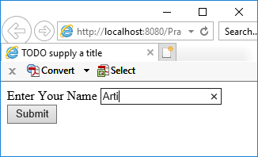 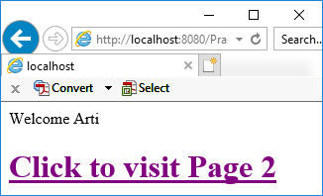

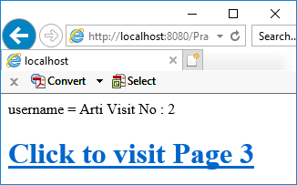 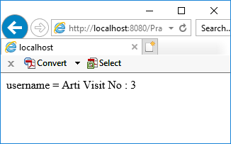

**2c) SESSION LOGOUT**

**File Name: index.html**

<html>

<head>

<title>TODO supply a title</title>

<meta charset="UTF-8">

<meta name="viewport" content="width=device-width, initial-scale=1.0">

</head>

<body>

**<form action="Page1" method="get">**

**Enter User ID <input type="text" name="txtName">**

**<br> <input type="reset" >**

**<input type="submit" value="Submit" >**

**</form>**

</body>

</html>

**File Name: Page1.java**

package mypack;

import java.io.IOException;

import java.io.PrintWriter;

import javax.servlet.ServletException;

import javax.servlet.http.Cookie;

import javax.servlet.http.HttpServlet;

import javax.servlet.http.HttpServletRequest;

import javax.servlet.http.HttpServletResponse;

import javax.servlet.http.HttpSession;

public class Page1 extends HttpServlet {

@Override

protected void doGet(HttpServletRequest request, HttpServletResponse response)

throws ServletException, IOException {

**response.setContentType("text/html;charset=UTF-8");**

**PrintWriter out = response.getWriter();**

**HttpSession hs = request.getSession(true);**

**if (hs.isNew()) {**

**String name = request.getParameter("txtName");**

**hs.setAttribute("uname", name);**

**hs.setAttribute("visit", "1");**

**} else {**

**int visit = Integer.parseInt((String) hs.getAttribute("visit")) + 1;**

**out.println("You Visited " + visit + "Times");**

**hs.setAttribute("visit", "" + visit);**

**}**

**out.println("Your Session ID " + hs.getId());**

**out.println("You Logged in at " + new java.util.Date(hs.getCreationTime()));**

**out.println("<h3><a href=Page2>Click for Page 2 </a></h3>");**

**out.println("<h3><a href=LogoutServlet>Click to logout </a></h3>");**

}

}

**File Name: Page2.java**

package mypack;

import java.io.IOException;

import java.io.PrintWriter;

import javax.servlet.ServletException;

import javax.servlet.http.Cookie;

import javax.servlet.http.HttpServlet;

import javax.servlet.http.HttpServletRequest;

import javax.servlet.http.HttpServletResponse;

import javax.servlet.http.HttpSession;

public class Page2 extends HttpServlet {

@Override

protected void doGet(HttpServletRequest request, HttpServletResponse response)

throws ServletException, IOException {

**response.setContentType("text/html;charset=UTF-8");**

**PrintWriter out = response.getWriter();**

**HttpSession hs = request.getSession(false);**

**out.println("<h3>Welcome Again on Page No. 2</h3>");**

**int visit = Integer.parseInt((String) hs.getAttribute("visit")) + 1;**

**out.println("<h3>You Visited " + visit + "Times</h3>");**

**hs.setAttribute("visit", "" + visit);**

**out.println("Your Session ID " + hs.getId());**

**out.println("You Logged in at " + new java.util.Date(hs.getCreationTime()));**

**out.println("<h3><a href=Page1>Click for Page 1 </a></h3>");**

**out.println("<h3><a href=LogoutServlet>Click to logout </a></h3>");**

}

}

**File Name: LogoutServlet.java**

package mypack;

import java.io.IOException;

import java.io.PrintWriter;

import javax.servlet.ServletException;

import javax.servlet.http.HttpServlet;

import javax.servlet.http.HttpServletRequest;

import javax.servlet.http.HttpServletResponse;

import javax.servlet.http.HttpSession;

public class LogoutServlet extends HttpServlet {

@Override

protected void doGet(HttpServletRequest request, HttpServletResponse response)

throws ServletException, IOException {

**response.setContentType("text/html;charset=UTF-8");**

**PrintWriter out = response.getWriter();**

**HttpSession hs = request.getSession();**

**if (hs != null) {**

**hs.invalidate();**

**}**

**out.println("You are Logged out now");**

}

}

**Output:**

